**Create Blob Storage Account through Azure Portal:**

* Go to All Services🡪Storage Accounts

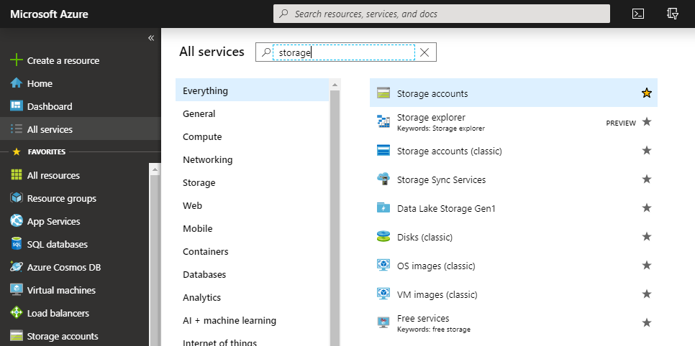

* Click on “+Add” to create a new storage account.
* Provide all the details and click on Next.

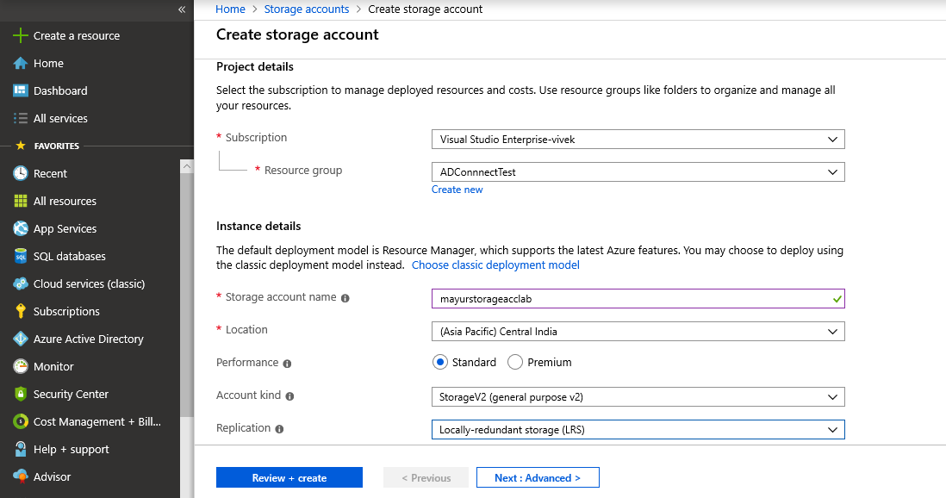

* Select the configuration as per your requirements and click on Next.

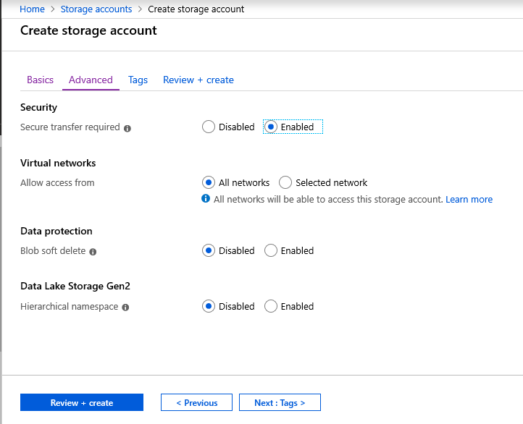

* Assign Tags if you want to assign any tag and click on next to review the configuration.

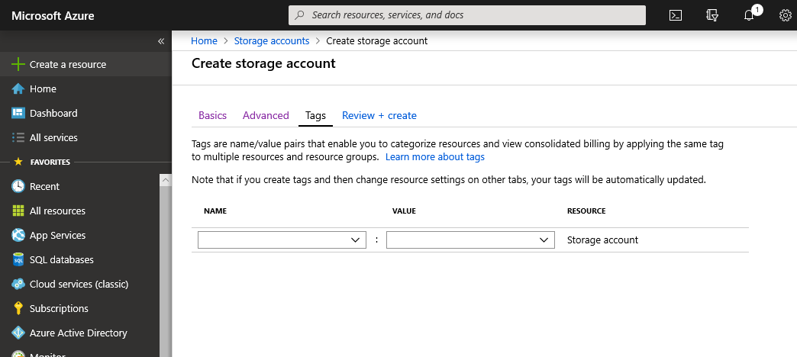

* Click on create to create the storage account.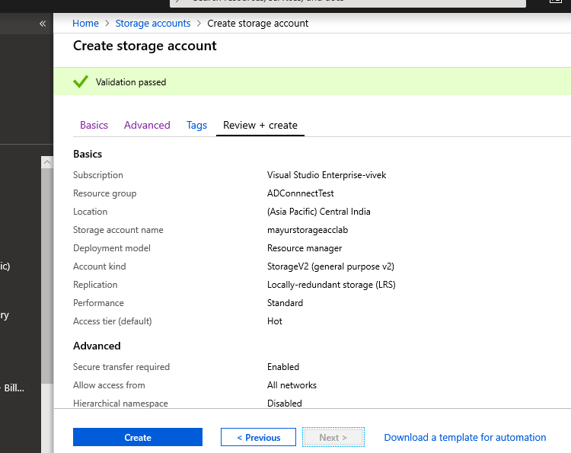
* Click on **Go to resource** to verify the storage account.

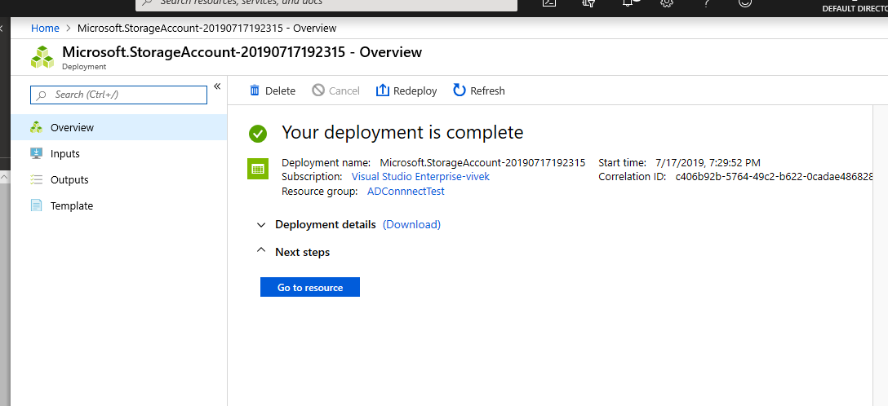

* Click on “Blob” to create Blob container in the storage account.

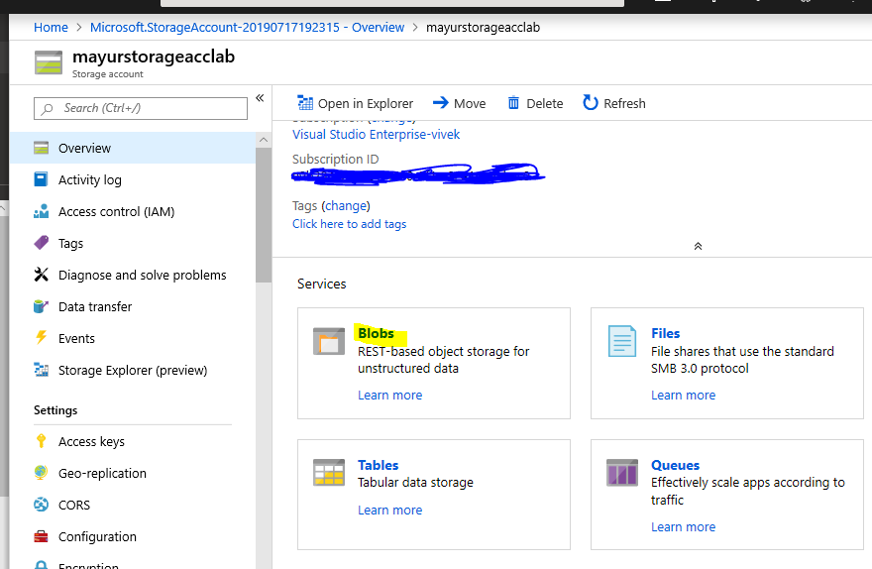

* Click on “+Container” to create a new container.

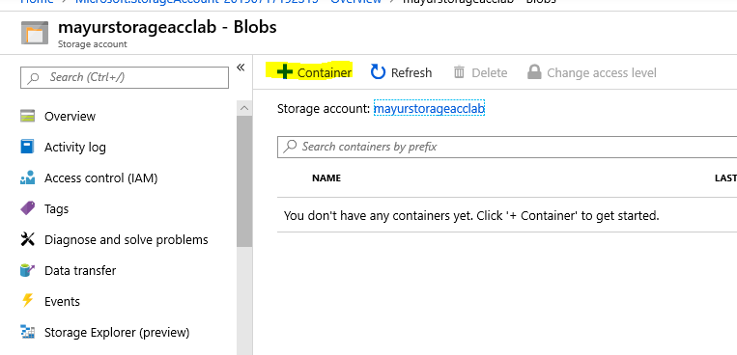

* Provide the container name, access level and click on **ok**.

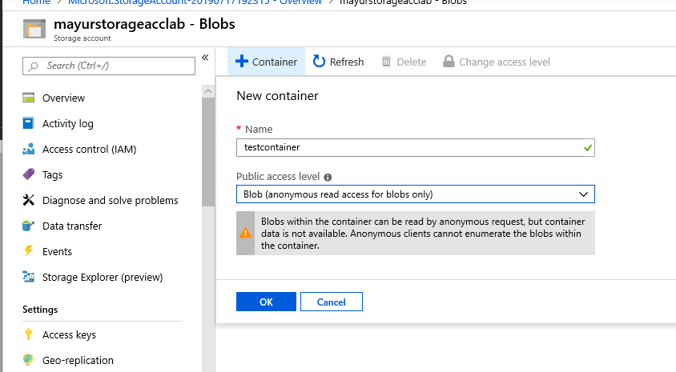

* Once the container is created click on refresh to see the container.

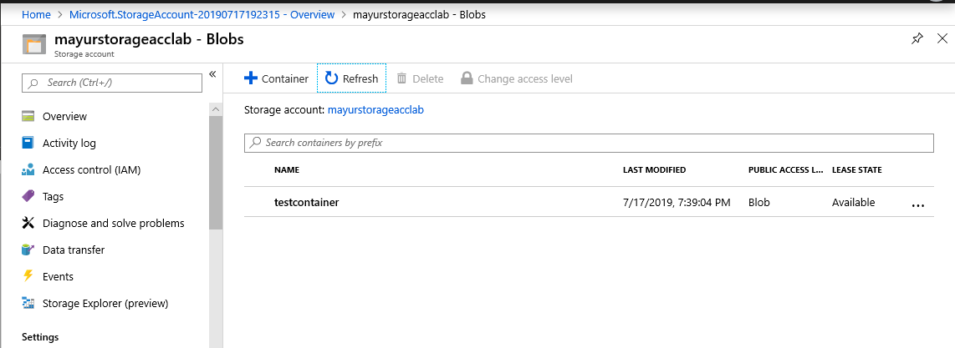

**Upload files in the blob Container:**

* Click on container and click on Upload to upload a file.

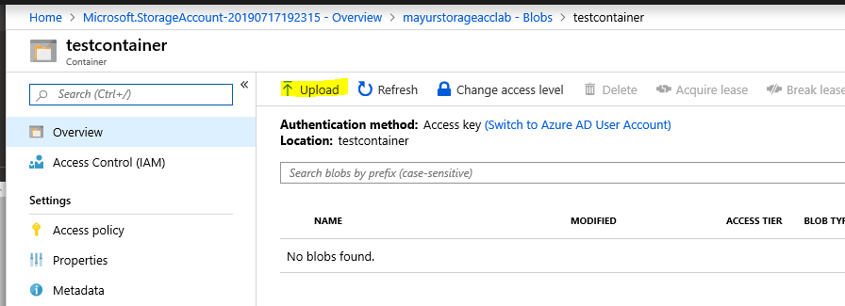

* Select the file and click on upload.

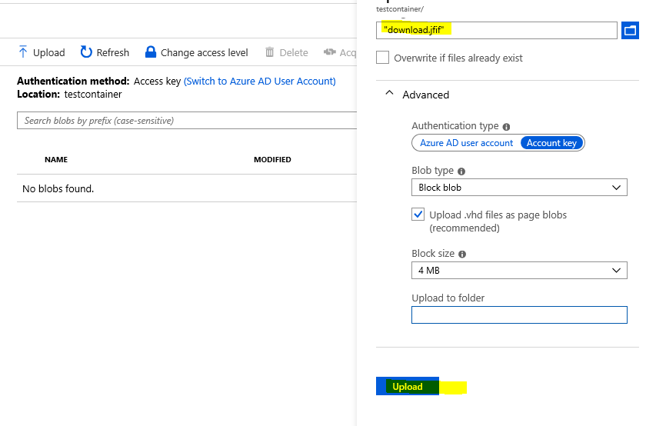

* Once the file is uploaded you can see the file.

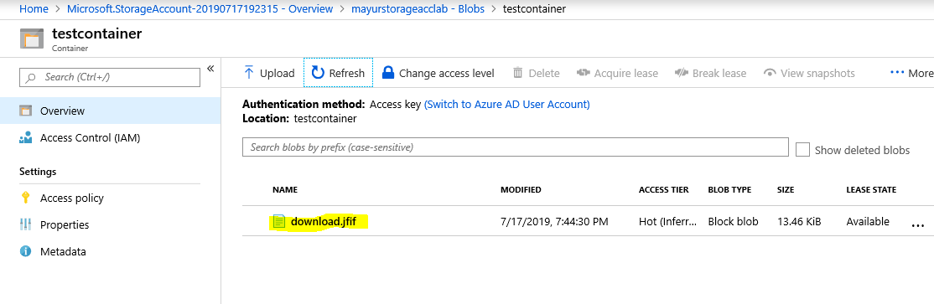

* Click on uploaded file and copy the URL.

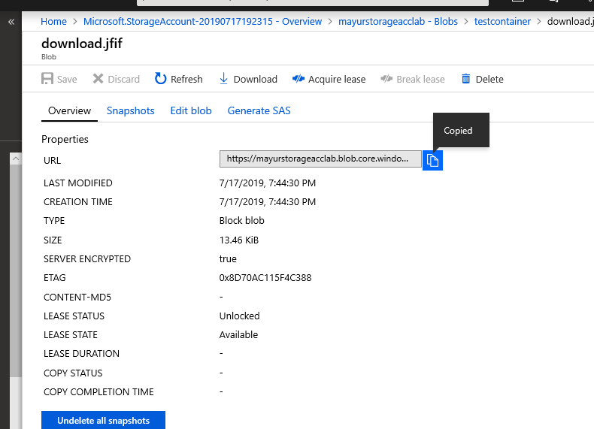

* Past the URL in any browser and check the verify if it is working.

